SULIT



SECP2523 DATABASE

SESSION 2024/2025 - SEMESTER 1
````

ALTERNATIVE ASSESSMENT REPORT: PHASE 1

Name | CHAU YING JIA
IC No. / Matric No. | A23CS0213
Year / Program | 2 / SECPH
Section | 01
Lecturer Name | DR. ROZILAWATI BINTI DOLLAH
Case Study | WBL Project
System Name | Koperasi KADA Online System
Group Name | TECHNICRAB

SECTION A (SYSTEM’S OVERVIEW)

1.1 | Overall Description
 |  | << Describe the system’s overview. >>
1.2 | Project Weaknesses or Improvement
 |  | << List the project’s weaknesses or improvement that can be made to the proposed system. Provide an explanation of the proposed module to overcome the weaknesses. >>
1.3 | Proposed Module
 |  | << Describe a new module to overcome the project’s weaknesses. >>
SECTION B (DATABASE PLANNING AND DESIGN)

2.1 | Conceptual ERD
 |  | << Draw a conceptual ERD to represent the proposed module. >>
2.2 | Logical ERD
 |  | <<Provide logical ERD of your module in the proposed system.>>
2.3 | Data Dictionary for Logical ERD
 |  | << Provide the data dictionary based on the logical ERD in Subsection 2.2.>>
2.4 | Relational Database Schema
 |  | <<Provide all relations database schema of your proposed module.>>
2.5 | Normalization
 |  | << Illustrate the normalization process up until BCNF to every relation listed in 2.5. At the end of this section, list all normalized relations achieved. >>

SECTION A (SYSTEM’S OVERVIEW)

Overall Description

Our objective is to help Koperasi Kakitangan KADA Kelantan Berhad in transitioning from their current manual system to a fully integrated digital platform. In this WBL project case study, the module I took in charge are the loan application process and the ability to view loan application status.

Currently, the cooperative handles loan application manually, which involve heavy paperwork, frequent mistakes, and delays in application review and approval. Members must physically visit the cooperative to submit their loan applications and repeatedly check to see if their applications have been approved. This method is not only time-consuming but also prone to data mismanagement and loss of important documents.

The proposed system introduces an online loan application feature where members can submit their applications digitally through our website system. Once submitted, the system automatically processes and stores the application data in a secure database, minimizing manual intervention and reducing errors. Members can easily access to real-time updates on the loan application status page, whether it is pending, approved, or rejected. Members can also watch monthly financial status through our system in the dashboard whenever they want to check on their savings or dividends. This eliminates the need for physical follow-ups and ensures members are promptly informed of any changes.

From the administrative perspective, the system streamlines the loan management process. Administrators can review and verify loan applications through a centralized platform, update application statuses, make financial adjustments for members and generate reports with just a few clicks. By automating repetitive tasks, the system allows staff to focus on critical decision-making and improve overall operational efficiency. The integrated reporting tools also enable administrators to track loan application trends and monitor performance metrics with ease.

The new system also feature a secure, centralized database to store and manage member information effectively. This will eliminate the need for members to repeatedly provide their personal details for every interaction. The database will also ensure easy access and retrieval of records, significantly reducing the time and effort required for administrative tasks. By digitizing the loan application process, the system not only improves data accuracy and security but also enhances communication between members and the admins.

In summary, the loan application module addresses the inefficiencies of the current manual system by providing a secure, efficient, and transparent digital solution. It simplifies the application process for members, reduces the administrative workload, and fosters better connectivity between stakeholders. This initiative represents a significant step toward modernizing the cooperative’s operations and delivering greater value to its members.

Group member’s name | Matric No. | Module
Cheryl Cheong Kah Voon | A23CS0060 | Member module ( financial status & manage profile)
Chau Ying Jia | A23CS0213 | Member module (apply for loan & loan application status)
Neo Li Xin | A23CS0253 | Admin module (generating reports)
Lau Yee Wen | A23CS0099 | Employee Module ( apply membership & membership application status)
Woo Cheng Shuan | A23CS0283 | Admin module (membership and loan application approval)

Project Weaknesses or Improvement

The system for loan application process and status updating for member viewing brings numerous benefits but it still has several potential weaknesses that need to be addressed to maximize its effectiveness and usability.

The first potential issue is that this system is develop by us, the most beginner in developing a complete system, I could say that it is still a very simple and designed for ease use system. Many features are still to be under improvement and many other features still could be implemented for the smoothest and best user experience. Members might face occasional website lagging, performance issues or technical issue. These issues need to be addressed. We should optimize the system’s performance and make regular testing, audits and page connection enhancements to make sure the system could run smoothly and no other technical issues to delay the loan application process. We can try to develop an automated error diagnostics feature to notify the administration for debugging once error is detected.

Another concern lies in the user interface design. Currently, the interface of our system could be improved, more neatly organized and maybe could be easier to navigate. Members might find it challenging to locate specific information when filling the loan application form or to complete actions or steps for example way to navigate to the view loan status page efficiently. A more informative and intuitive interface is necessary to improve user engagement and overall system usability. We should modify the interface focuses on simplicity, neatness and easy navigation to make it more user-friendly and accessible.

These are the weaknesses and improvements we can make to ensure a inclusive, reliable and secure system, ultimately fostering trust and satisfaction among all stakeholders.

1.3Proposed Module

To address the weaknesses identified in current loan system module, I will propose the development module called “System improvement and Optimization Module”. This module will enhance the system performance, improve user interface design, and provide robust solution to overcome technical and operational challenges. Here is a list of what can we do in this module to reach the expectations of our complete system:

Optimize codes configurations for better performance

Implement a load balancer to distribute traffic

Redesign the user interface to be more intuitive and neatly organized

Build in automated system diagnostics to automatic detect and notify of system issues
- Strengthen security by implementing multi-layered authentication, encrypted communication protocols, and secure user access management.

By incorporating this module, the loan system will overcome its current weaknesses to make a platform that meets the expectations of all stakeholder while preparing for future advancements too.

SECTION B (DATABASE PLANNING AND DESIGN)

2.1 Conceptual ERD

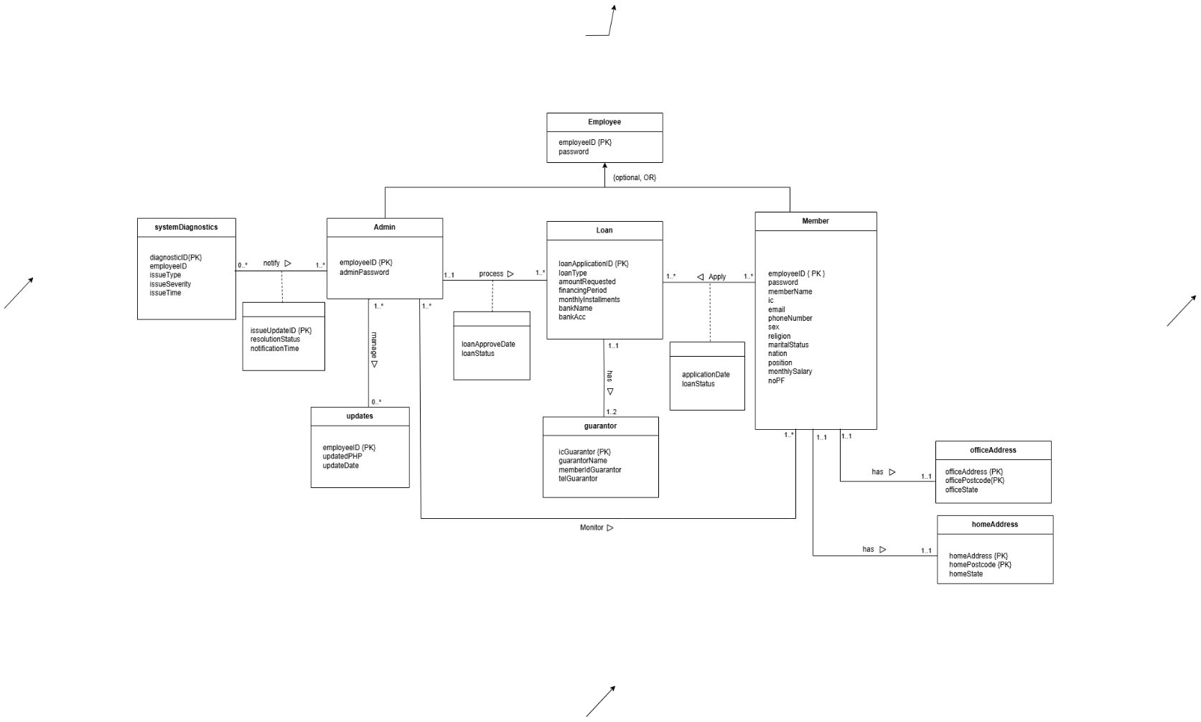

2.2 Logical ERD

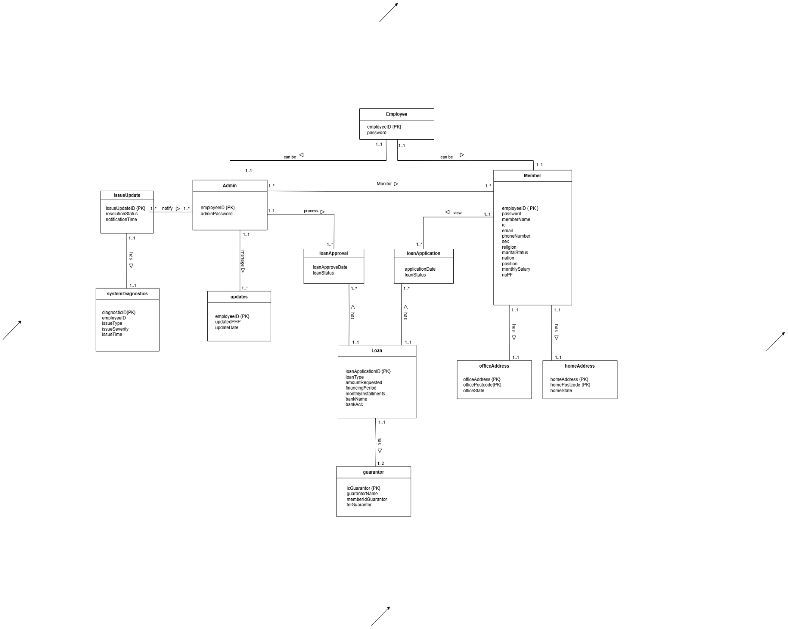

2.3 Data Dictionary for Logical ERD

2.3.1 Identifying Entiti

Entity Name | Description | Aliases | Occurrence
Employee | Represents any person accessing the KADA system | New user, guest | Occurs when first-time user visit the website
Member | Represents registered users who have created KADA accounts | Members | Occurs when new user or guest register as a member
Admin | Represents the system admin who responsible for managing KADA system | Administrator, staff, board director | Occurs when system built and processing members’ account activity
Loan | Represents loan applications submitted by members | Loan application record | Occurs when member apply for loan
guarantor | Represents information about members’ loan guarantors | Members’ loan application guarantor details | Occurs when member apply for loan
officeAddress | Stores members’ office address | Members’ personal information | Occurs when employer register as a member
homeAddress | Stores members’ house address | Members’ personal information | Occurs when employer register as a member
systemDiagnostics | Stores information when issues is detected | Admin | Occurs when detected there is an issue or error in the system
updates | Stores history of updated PHP files and dates of modification | Admin | Occurs when admin wants to modify codes or interface for better performances

2.3.2 Identifying Relationship Types

Entity Name | Multiplicity | Relationship | Entity Name | Multiplicity
Employee | 1..1  1..1 | can be  can be | Admin  member | 1..1  1..1
Member | 1..1  1..1  1..1 | Has  Has  View | homeAddress  officeAddress  loanApplication | 1..1  1..1  1..*
Admin | 1..*  1..1  1..1 | monitor  process  manage | Member  loanApproval  updates | 1..*  1..*  1..*
issueUpdate | 1..*  1..1 | notify  has | admin  systemDiagnostics | 1..*  1..1
Loan | 1..1  1..1  1..1 | has  has  has | guarantor  loanApproval  loanApplication | 1..2  1..*  1..*

2.3.3 Attributes description

Entity Name | Attributes | Data Type & Length | Description | Nulls | Multi-  valued | Example
Employee | employeeID(PK) | INT(4) | Unique ID for the employee | No | No | 0001
 | password | VARCHAR (20) | User’s account password | No | No | P12345W
Member | employeeID (PK) | INT(4) | Unique ID for member | No | No | 0001
 | password | VARCHAR (30) | Password for member login | No | No | P12345W
 | memberName | VARCHAR (80) | Name of the member | No | No | Ali Abu
 | ic | CHAR (12) | Identification number of the member | No | No | 040101081234
 | email | VARCHAR (30) | Member’s email address | No | No | member@gmail.com
 | phoneNumber | VARCHAR (15) | Contact number of the member | No | No | 0123456789
 | sex | CHAR (1) | Gender of the member (M/F) | No | No | Female
 | religion | VARCHAR (30) | Religion of the member | No | No | Buddha
 | maritalStatus | VARCHAR (15) | Marital status | No | No | Married
 | nation | VARCHAR (30) | Nationality of the member | No | No | Malaysia
 | position | VARCHAR (30) | Working position of the member | No | No | Data Engineer
 | monthlySalary | INT (6) | Member’s monthly salary | No | No | 3000
 | noPF | INT(4) | Member no PF | No | No | 5678
Admin | employeeID (PK) | INT(4) | Unique ID for admin | No | No | 4567
 | adminPassword | VARCHAR (20) | Password of the admin | No | No | noahlim
Loan | loanType | VARCHAR(30) | Type of loan | No | No | AL_BAI
 | loanApplicationID (PK) | VARCHAR (20) | Unique ID for loan application | No | AUTO-INCREMENT | 0003
 | amountRequested | INT (7) | Amount requested for the loan | No | No | 3000
 | financingPeriod | INT(2) | Loan repayment period in months | No | No | 5
 | monthlyInstallments | INT(7) | Monthly repayment amount | No | No | 650
 | bankName | VARCHAR (50) | Bank name for loan transfer | No | No | RHB
 | bankAccount | VARCHAR (20) | Bank account number | No | No | 01234567890
guarantor | GuarantorName | VARCHAR (80) | Name of the guarantor | No | No | Evelyn Lee
 | IcGuarantor (PK) | INT (12) | Identification number of the member | No | No | 040101081234
 | memberIdGuartor | INT (4) | Unique ID for member’s guarantor | No | No | 8888
 | telGuarantor | VARCHAR (15) | Contact number of the member’ guarantor | No | No | 0123456789
officeAddress | officeAddress | VARCHAR (100) | Address of member’s office | No | No | 3A, Jalan Permai
 | officePostcode | INT(6) | Postcode of office address | No | No | 31400
 | officeState | VARCHAR(30) | Office located state | No | No | Perak
homeAddress | homeAddress | VARCHAR (100) | Address of member’s house | No | No | 36, Jalan Indah Sakti
 | homePostcode | INT(6) | Postcode of home address | No | No | 31400
 | officeState | VARCHAR (30) | Office located state | No | No | Perak
issueUpdate | issueUpdateID | INT (10) | Unique ID for each update | No | AUTO-INCREMENT | 00000 00333
 | resolutionStatus | VARCHAR (10) | Status on resolving errors | No | No | pending
 | notificationTime | TIMESTAMP | Time when issues id detected and notification is sent to admin | No | No | 2025-01-01 00:00:01
systemDiagnostic | diagnosticID(PK) | INT (10) | Unique ID for each diagnostic | No | AUTO-INCREMENT | 00000 01117
 | employeeID | INT (4) | Unique ID for employee who diagnose the issue | No | No | 0004
 | issueType | INT (20) | Type of issue | Yes | No | Server down
 | issueSeverity | VARCHAR(20) | Severity of that issue | No | No | low
 | issueTime | TIMESTAMP | Time when issue appear | No | No | 2025-01-01 00:00:01
updates | employeeID | INT (4) | Unique ID for employee who diagnose the issue | No | No | 0135
 | updatedPHP | VARCHAR(40) | Name of PHP file of the file that make changes | No | No | Permohonanloan.php
 | updateDate | TIMESTAMP | Date and time when admin made an update | No | No | 2025-01-01 00:00:01
loanApproval | loanApprovalDate | TIMESTAMP | Date and time when loan is approve or decline | No | No | 2025-01-01 00:00:01
 | loanStatus | VARCHAR (10) | Status on loan application | No | No | rejected
loanApplication | applicationDate | TIMESTAMP | Date and time when member apply for loan | No | No | 2025-01-01 00:00:01
 | loanStatus | VARCHAR (10) | Status on loan application | No | No | rejected

2.4 Relational Database Schema
EMPLOYEE (employerID, password)
PK: employeeID

ADMIN (employeeID, adminPassword)
PK: employeeID
FK: employeeID references EMPLOYEE ( employeeID )

MEMBER(employeeID, password, memberName, ic, email, phoneNumber, sex, religion, maritalStatus, nation, position, monthlySalary, noPF)
PK: employeeID
FK: employeeID references EMPLOYEE ( employeeID )

UPDATES (employeeID, updatePHP, updateDate)
PK: employeeID
FK: employeeID references ADMIN ( employeeID )

ISSUEUPDATE (issueUpdateID, resolutionStatus, notificationtime, employeeID)
PK: issueUpdateID
FK: employeeID references ADMIN ( employeeID )

SYSTEMDIAGNOSTICS (diagnosticID, employeeID, issueType, issueSeverity, issueTime, issueUpdateID)
PK: diagnosticID
FK: employeeID references ADMIN ( employeeID )
FK: issueUpdateID references ISSUEUPDATE (issueUpdateID)

LOAN(loanApplicationID, loanType, amountRequested, financingPeriod, monthlyInstallments, bankName, bankAcc)
PK: loanApplicationID

LOANAPPROVAL(employeeID, loanApplicationID, loanApproveDate, loanStatus)
PK: employeeID, loanApplicationID
FK: employeeID references ADMIN(employeeID)
FK: loanApplicationID references LOAN(loanApplicationID)

LOANAPPLICATION(employeeID, loanApplicationID, applicationDate, loanStatus)
PK: employeeID, loanApplicationID
FK: employeeID references MEMBER(employeeID)
FK: loanApplicationID references LOAN(loanApplicationID)

GUARANTOR ( icGuarantor, loanApplicationID, guarantorName, memberIdGuarantor, telGuarantor)
PK: icGuarantor, loanApplicationID
FK: loanApplicationID references LOAN (loanApplicationID )

OFFICEADDRESS (officeAddress, officePostcode, officeState)
PK: officeAddress, officePostcode

HOMEADDRESS( homeAddress, homePostcode, homeState)
PK: homeAddress, homePostcode

2.5 Normalization
- employee – admin
1NF:
Employee_Admin (employeeID, password, adminPassword)
PK: employeeID

2NF:
Employee (employeeID, password)
PK: employeeID
Admin (employeeID, adminPassword)
PK: employeeID
FK: employeeID references Employee(employeeID)

3NF:
No changes, already in 3NF.
- employee – member
1NF:
Employee_Member( employeeID, password, memberName, ic, email, phoneNumber, sex, religion, maritalStatus, nation, position, monthlySalary, noPF)
PK: employeeID

2NF:
Employee (employeeID, password, position, monthlySalary)
PK: employeeID
Member (employeeID, memberName, ic, email, phoneNumber, sex, religion, maritalStatus, nation,noPF)
PK: employeeID

Employee_Member( employeeID)
PK: employeeID
FK: employeeID references Employee(employeeID)
FK: employeeID references Member(employeeID)

3NF:
Does not exist.

- admin – member
1NF:
Admin_member(employeeID, adminPassword, password, memberName, ic, email, phoneNumber, sex, religion, maritalStatus, nation, position, monthlySalary, noPF)
PK: employeeID

2NF:
Admin (employeeID, adminPassword)
PK: employeeID
Member ( employeeID, password, memberName, ic, email, phoneNumber, sex, religion, maritalStatus, nation, position, monthlySalary, noPF)
PK: employeeID
Admin_member ( employeeID)
PK: employeeID
FK: employeeID references Admin(employeeID)
FK: employeeID references Member(employeeID)

3NF:
Does not exist.
- admin – issueUpdate
1NF:
Admin_issueUpdate ( employeeID, issueUpdateID, adminPassword, resolutionStatus, notificationTime)
PK: employeeID, issueUpdateID

2NF:
Admin(employeeID, adminPassword)
PK: employeeID
IssueUpdate(issueUpdateID, resolutionStatus, notificationTime)
PK: issueUpdateID
Admin_issueUpdate ( employeeID, issueUpdateID, adminPassword, resolutionStatus, notificationTime)
PK: employeeID, issueUpdateID
FK: employeeID references Admin (employeeID)
FK: issueUpdateID references issueUpdate (issueUpdateID)

3NF:
Does not exist.

- issueUpdate – systemDiagnostics
1NF:
Issue_SystemDiagnostics (diagnosticID, issueUpdateID, employeeID, resolutionStatus, issueType, issueSeverity, issueTime, notificationTime)
PK: diagnosticID, issueUpdateID
2NF:
IssueUpdate(issueUpdateID, resolutionStatus, notificationTime)
PK: issueUpdateID
FK: employeeID references Admin(employeeID)
SystemDiagnostics(diagnosticID, employeeID, issueType, issueSeverity, issueTime)
PK: diagnosticID
FK: employeeID references IssueUpdate(employeeID)
Issue_SystemDiagnostics (diagnosticID, issueUpdateID, employeeID, resolutionStatus, issueType, issueSeverity, issueTime, notificationTime)
PK: diagnosticID, issueUpdateID
FK: diagnosticID references issueUpdate ( diagnosticID )
FK: IssueUpdateID references issueUpdate ( IssueUpdateID)
FK: employeeID references Admin(employeeID)
3NF:
Does not exist.
- admin – updates
1NF:
Admin_Updates(employeeID, adminPassword, updatePHP, updateDate)
PK: employeeID

2NF:
Admin(employeeID, adminPassword)
PK: employeeID
Updates(employeeID, updatePHP, updateDate)
PK: employeeID
FK: employeeID references Admin(employeeID)

3NF:
Does not exist.

- admin – loanApproval
1NF:
Admin_Updates(employeeID, adminPassword, loanApproveDate, loanStatus)
PK: employeeID

2NF:
Admin (employeeID, adminPassword)
PK: employeeID
LoanApproval (employeeID, loanApproveDate, loanStatus)
PK: employeeID,
FK: employeeID references Admin(employeeID

3NF:
Does not exist.

- loanApproval – loan
1NF:
LoanApproval_Loan(employeeID, loanApplicationID, loanApproveDate, loanStatus, loanType, amountRequested, financingPeriod, monthlyInstallments, bankName, bankAcc)
PK: employeeID, loanApplicationID

2NF:
Loan(loanApplicationID, loanType, amountRequested, financingPeriod, monthlyInstallments, bankName, bankAcc)
PK: loanApplicationID
LoanApproval(employeeID, loanApplicationID)
PK: employeeID, loanApplicationID
FK: loanApplicationID references Loan(loanApplicationID)

3NF:
Does not exist.

- loanApplication – loan
1NF:
LoanApplication_Loan(employeeID, loanApplicationID, applicationDate, loanStatus, loanType, financingPeriod, monthlyInstallments, bankName, bankAcc)
PK: employeeID, loanApplicationID

2NF:
Loan (loanApplicationID, loanType, financingPeriod, monthlyInstallments, bankName, bankAcc)
PK: loanApplicationID
LoanApplication(employeeID, loanApplicationID, applicationDate, loanStatus)
PK: employeeID, loanApplicationID
FK: employeeID references Member (employeeID)
FK: loanApplicationID references Loan(loanApplicationID)

3NF:
Does not exist.
- loan – guarantor
1NF:
loan_guarantor(loanApplicationID, icGuarantor, loanType, amountRequested, financingPeriod, monthlyInstallments, bankName, bankAcc, guarantorName, memberIdGuarantor, telGuarantor)
PK: loanApplicationID, icGuarantor

2NF:
Guarantor (icGuarantor, guarantorName, memberIDGuarantor, telGuarantor)
PK: icGuarantor
loan_guarantor (loanApplicationID, icGuarantor, amountRequested, financingPeriod, monthlyInstallments, bankName, bankAccount)
PK: loanApplicationID, icGuarantor
FK: icGuarantor references guarantor (icGuarantor)

3NF:
Does not exist.

- member – loanApplication
1NF:
member_loanApplication ( employeeID, loanApplicationID, password, memberName, ic, email, phoneNumber, sex, religion, maritalStatus, nation, position, monthlySalary, noPF, applicationDate, loanStatus)
PK: employeeID, loanApplicationID

2NF:
Member ( employeeID, password, memberName, ic, email, phoneNumber, sex, religion, maritalStatus, nation, position, monthlySalary, noPF )
PK: employeeID
loanApplication (loanApplicationID, employeeID, applicationDate, loanStatus)
PK: loanApplicationID, employeeID
FK: employeeID references member (employeeID)
FK: loanApplicationID references loan (loanApplicationID)

3NF:
Does not exist.

- member – officeAddress
1NF:
Member_OfficeAddress (employeeID, officeAddress, officePostcode, officeState)
PK: employeeID, officeAddress

2NF:
Member ( employeeID, password, memberName, ic, email, phoneNumber, sex, religion, maritalStatus, nation, position, monthlySalary, noPF )
PK: employeeID
OfficeAddress (officeAddress, officePostcode, officeState, employeeID)
PK: officeAddress
FK: employeeID references Member(employeeID)

3NF:
Does not exist.

- member – homeAddress
1NF:
Member_homeAddress (employeeID, homeAddress, homePostcode, homeState)
PK: employeeID, homeAddress

2NF:
Member ( employeeID, password, memberName, ic, email, phoneNumber, sex, religion, maritalStatus, nation, position, monthlySalary, noPF )
PK: employeeID
HomeAddress (homeAddress, homePostcode, homeState, memberID)
PK: homeAddress
FK: memberID references Member(memberID)

3NF:
Does not exist.

